Directions: The goal of the following problems is to help challenge and deepen your understanding of the current topic. Don’t assume that you will know how to answer every question. You will work with at least two other students in the class to try and find solutions and write arguments for each of the following questions. Be sure that you question your classmates’ reasoning. If you don’t understand how they are getting something, you should ASK THEM TO EXPLAIN! Being able to defend your reasoning is important and so you are actually helping them by asking them to explain.

Challenge Questions

- A 3lb bucket containing 20lbs of water is hanging at the end of a 20ft rope that weighs 4oz/ft. The other end of the rope is attached to a pulley.
- How much work is required to wind the length of rope onto the pulley?

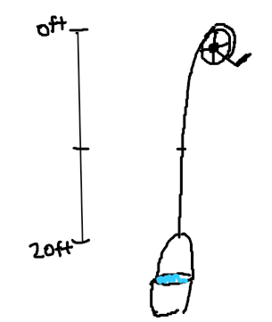
We note that the rope weighs 4oz/ft = 1/4lbs/ft.
Suppose we have a piece of the rope that is ft long, then it would require a force of to move. Based on how we have labeled the diagram at the right we would also have that .
Therefore, the total work required to pull in the entire rope would be

Should be done by letting represent the overall force

Let x represent how much of the rope has been pulled onto the pulley.
Then we have
The bounds then represent how much rope is on the pulley from start to finish.
Therefore we have

- How much work is required to wind half of the rope onto the pulley?

The only thing that changes here would be the bounds that we use and the distance that we pull up the bucket. Based on how we have labeled the diagram above the new bounds would only go from 10 to 20.
Therefore, the total work required to pull in half of the rope would be

CORRECT WAY

- A chain lying on the ground is 10 meters long and its mass is 80 kg. How much work is required to raise one end of the chain to a height of 6m?

The chain has a mass of .

For a single “slice” of chain
A slice of chain has a mass of
The force required to lift a “piece” of the chain is given by
We must lift each piece of chain
Therefore the work required to move a single piece of chain is given by

The whole chain

Therefore, the work for entire process is given by .
We calculate that

OR
Let x represent how much of the chain has been lifted off of the floor.
Then we have and so
The bounds then represent how much chain is in the air from start to finish.
Therefore we have

- A cylindrical tank has a radius of 3m and a height of 6m and is filled with water.

- How much work is required to pump one third of the water out of top of the tank. (The density of water is )

For a single cross section of the tank we know that:

Therefore, the work done on a slice of water is given by:
Thus, the total work done is approximately.
To get the exact work done, we let the number of slices of water approach infinity, and we get:

- Suppose that in part (a) the pump pumping the water out of the tank breaks down after of work has been done. What is the depth of the water remaining in the tank?

We need to set up an integral that produces this amount of work. What is unknown is the lower bound of the integral.
This must mean that .
Therefore, we need to solve
Clearly is absurd since this height resides outside of the tank.
Therefore, it must be the case that and so the height of the water in the tank is .

- A trough is in the shade of a half drum (half a cylinder lying on its side). The length of the tank is 6 feet and the radius is 1 foot. Assuming it is full of water, find the work done in pumping the water to the top of the tank. (The density of the water is )
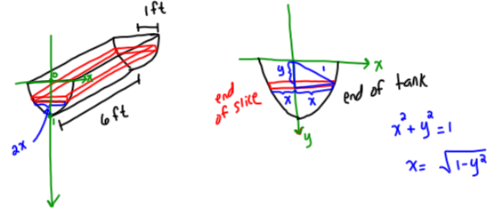

Suppose we partition the water in the tank into n “slices” of thickness .

Setup:
For a single cross section of the tank we know that:

Therefore, the work done on a slice of oil is given by:
Thus, the total work done is approximately.
To get the exact work done, we let the number of slices of water approach infinity, and we get:
Let and then . Our bounds become . Therefore,

- A spherical tank has a radius of 3ft and is filled with water. Setup, but do not compute, an integral to represent how much work is required to pump all of the water out of the tank. (The density of water is ). Hint: The equation for a sphere is when the sphere is centered at the origin. Draw and label your tank so that it is centered at the origin.

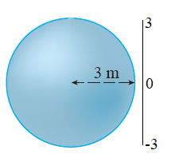
We first draw a picture of our tank and label our depth in the following way.

For a single cross section of the tank we see that , but we need to determine a formula for r.
If our slice of water is at the height of , then our sphere equation would reduce to be . This shows us that at this height we are working with a circle with radius (You can check to see that this makes sense at the heights of ).

Therefore, for a single cross section of the tank we know that:

Therefore, the work done on a slice of oil is given by:
Thus, the total work done is approximately.
To get the exact work done, we let the number of slices of water approach infinity, and we get:

- Kyle jogs along the curve defined by from to . Mallory jogs along the straight line connecting those two points. Kyle and Mallory both start from at the same time and Kyle jogs at a speed of units/s. What is the speed at which Mallory must run so that she arrives at at the same time as Kyle?

First note that and this is a continuous function on .
So, the distance that Kyle needs to cover is given by

Since Kyle is jogging at a speed of units/s he will complete his run in the following amount of time..

The distance that Mallory needs to cover is simply given by units.
In order to finish her run in the same amount of time as Kyle she will need to run at the following speed.

units/s

- Consider the curve defined by
.
- Setup, but do not evaluate, an integral which represents the length of this curve.

We see that is continuous on so

- Setup, but do not evaluate, an integral which represents the surface area of the solid obtained by rotating this curve about the x-axis.

We see that is continuous on and y is a non-negative function on so,
- Setup, but do not evaluate, an integral which represents the surface area of the solid obtained by rotating this curve about the y-axis.

We cannot solve this function easily for x on the interval , instead we will setup this integral with respect to x. Note that since cannot produce all values of x on .

- Suppose is a function with the following properties:
- is a differentiable function.
- for all values of x.
- Over any interval, the area between the curve and the x-axis is equal to the arclength of the curve .
- Rewrite property (iii) using integral notation.

Based on what is stated in (i), for any interval it must be the case that.

- Use the Fundamental Theorem of Calculus (Part 1) to confirm that the integrands from part (a) are equal.

Since we know that is differentiable everywhere it must be the case that is continuous everywhere. This implies that is differentiable and therefore continuous everywhere. So, the functions and are continuous on any interval.

Let the upper bound be t and thus , then by the FTCP1 we have that for any value of t we have.

Therefore, the integrands are the same.

- Use your answer from part (b) to help determine a formula for .
This means that and therefore

- Show that there are actually infinitely many possible functions that satisfies all the stated properties.

In part (c) it was determined that
Then, by property (iv) we know that and this implies
for some integer value k.

Therefore, there are infinitely many functions that satisfy the given properties.

